AIM: To write and execute a program in R to print “hello,world!” by using r programming

ALGORITHAM:

* Begin the process of writing and executing the r program
* Open r software or an integrated development environment (IDE) like R studio
* Write the code : print(“Hello,world!”)
* Save the code
* Execute the code in the R console or Run
* Output “Hello,world!”

Program:

My_function <-function(){

Print(“Hello,world!”)

}

OUTPUT:

Hello World

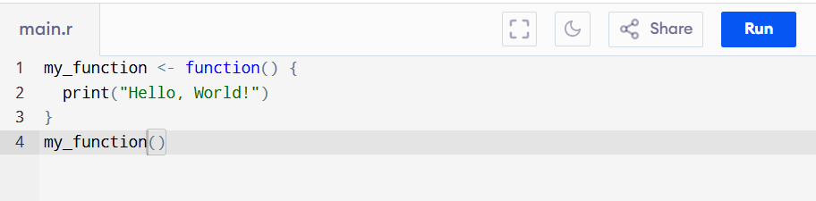

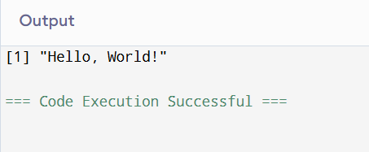

Result:

The program successfully prints “hello,world” by using r program